Singareni Collieries Women’s Degree College, Kothagudem
BIOTECHNOLOGY DEPARTMENTAL ACTIVITIES
2021-2022
DATE | NAME OF THE ACTIVITY | PHOTO
21-06-2021 | Participated in International Yoga Day Celebrations at SCWDC.
24-6-2021 | Published Research paper on “In vitro antimicrobial activity of leaf, stem fruit and root crude extracts of Momordica cymbalaria Fenzl: A medicinally important cucurbit”. In International Journal- Journal of Pharmacognosy and Phytochemistry | 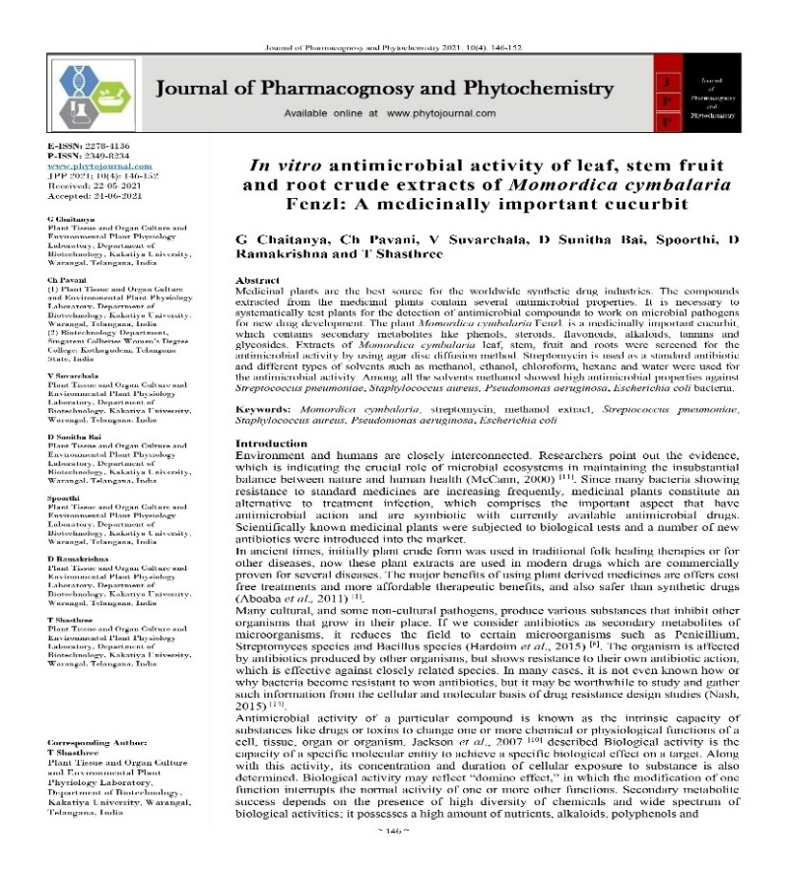
11-07-2021 | Participated in Webinar on account of “World Population Day” at SCWDC.
10-08-2021 | Attended National Webinar on “Research, Innovation & Ranking” organized by IIC, Ministry of Education Initiative. | 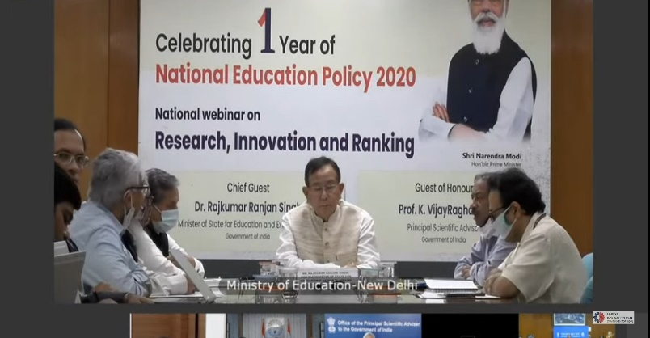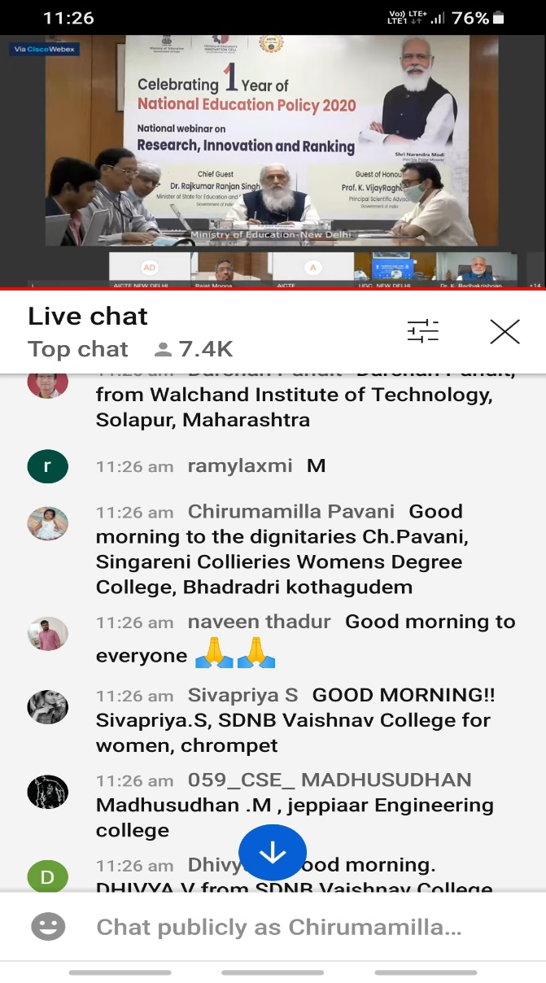
27-08-2021 | Participated in “National Webinar on Research and Career Opportunities in Life Sciences” | 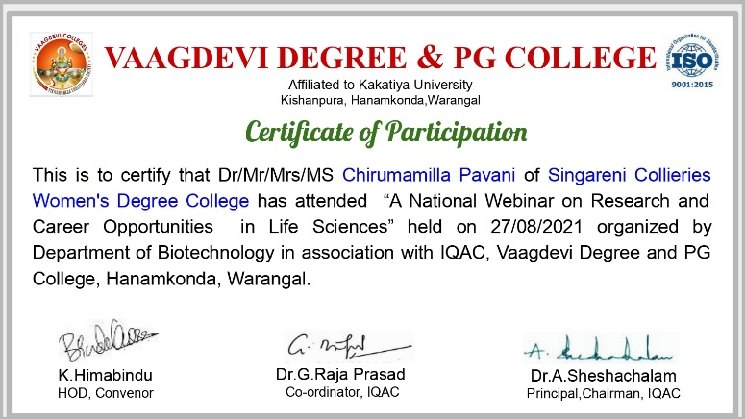
28-08-2021 | Participated in Webinar on “Role of Herbal Resources in Boosting Immunity” | 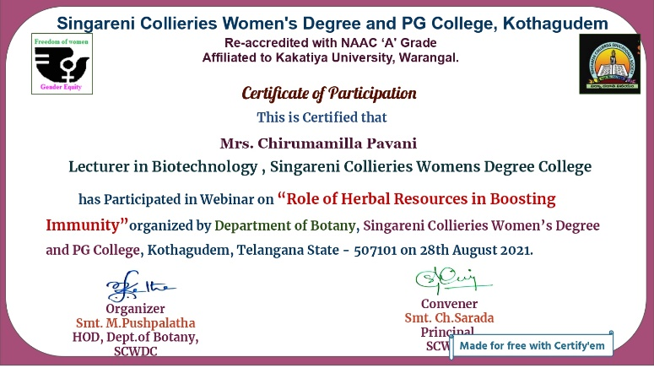
16-09-2021 | Conducted Online quiz competition on the event of “World Ozone Day”. | 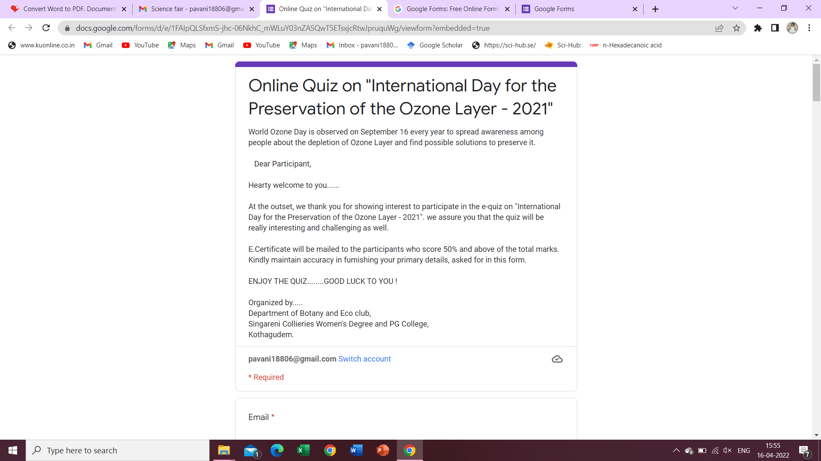
03-10-2021 | Published research paper titled- Qualitative and quantitative evaluation of secondary metabolites of different plant extracts of Nothapodytes foetida (Wight) Sleumer, an important endangered medicinal tree. In International Scientific Journal- “World Scientific News”. | 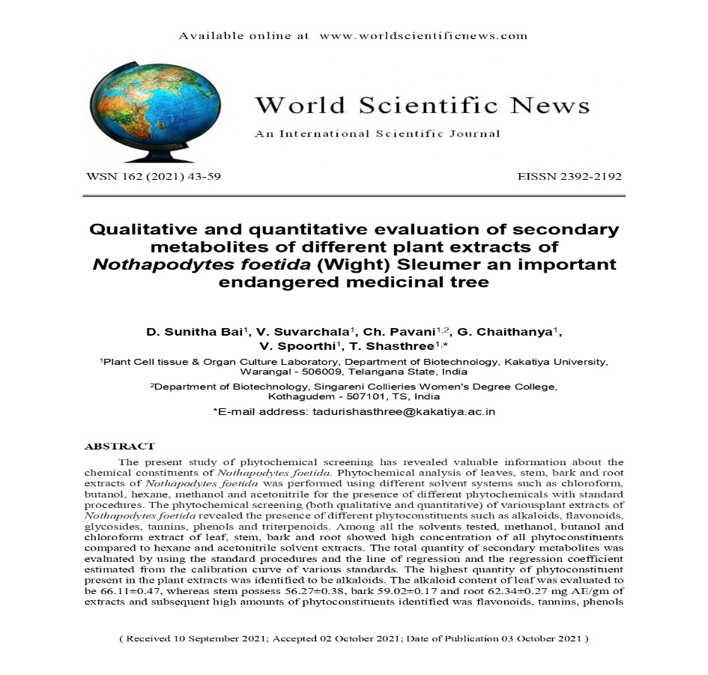
05-10-2021 | Attended Webinar on “ Swachchta- A Comprehensive Perspective” at SCWDC.
20-10-2021 | Presented PhD final viva-voce on thesis entitled- “ Solanum khasianum- Biotechnology Perspectives” at Kakatiya University, Warangal for the award of PhD degree. | 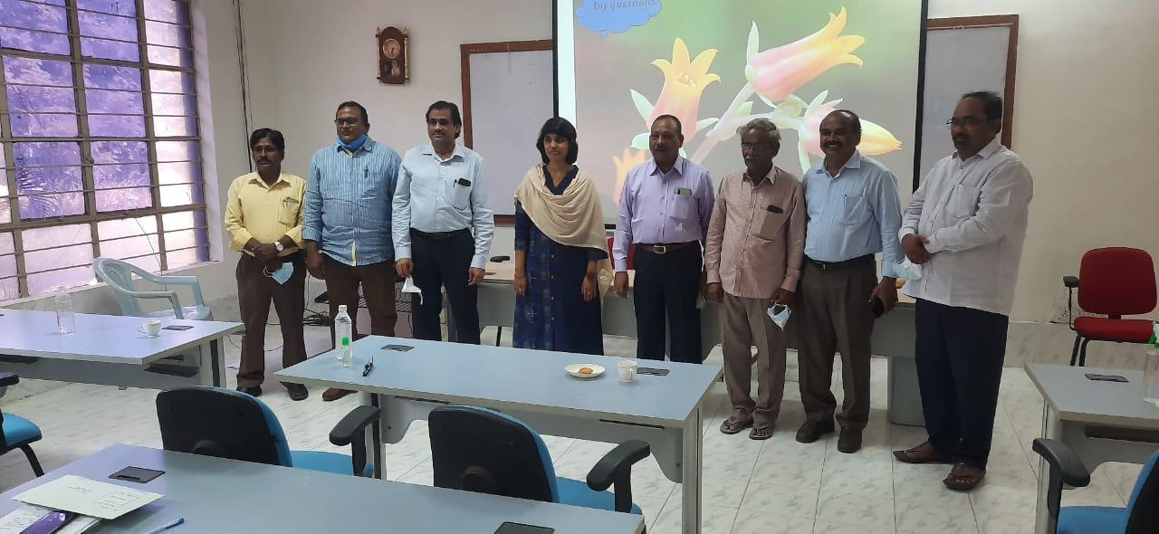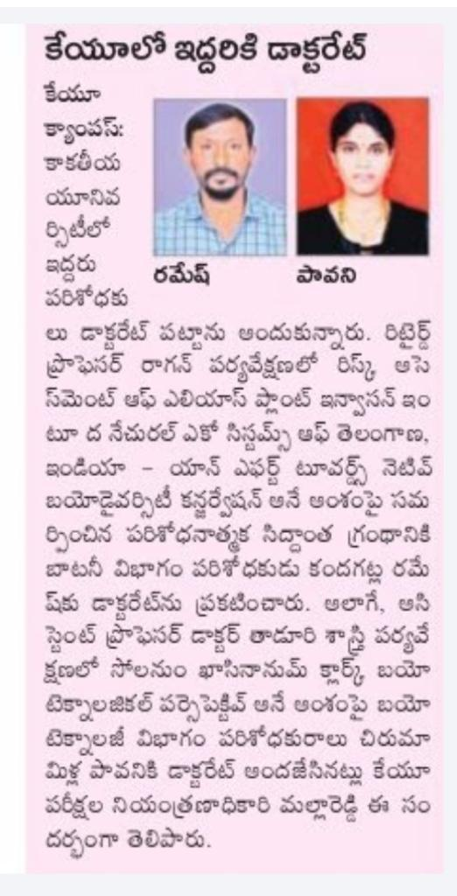
02-11-2021 | Plantation program at SCWDC campus | 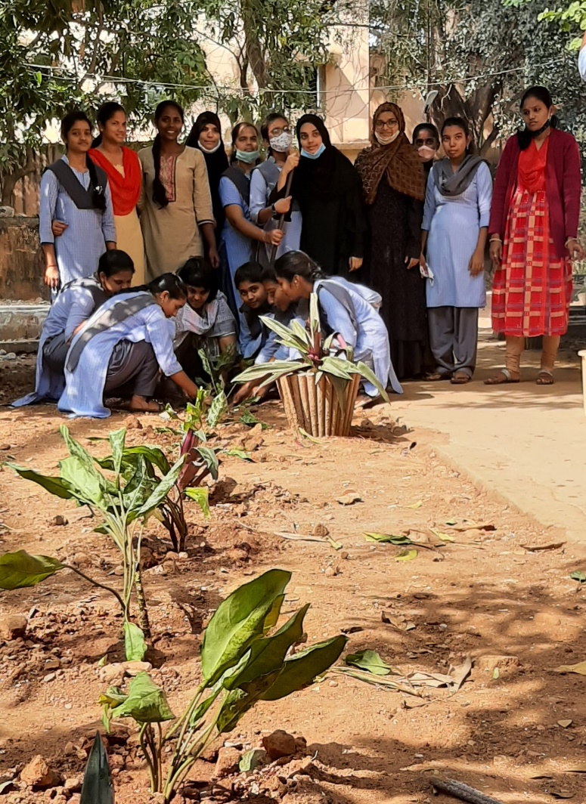
01-12-2020 | Participated in Institutions Innovation Council (2020-21) Annual Performance Result Announcement- organized by MHRD Innovation Cell. | 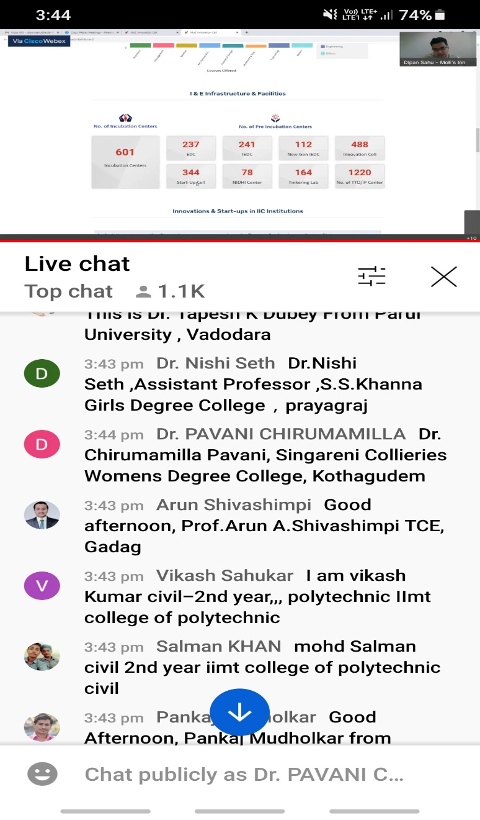
06-12-2021 to 08-12-21 | Participated in 3 day “Heartfulness Meditation Program” at SCWDC.
23-12-2021 | Exhibited “Global Warming and Flue gas” working models in Singareni Day Celebrations at Prakasham Stadium. | 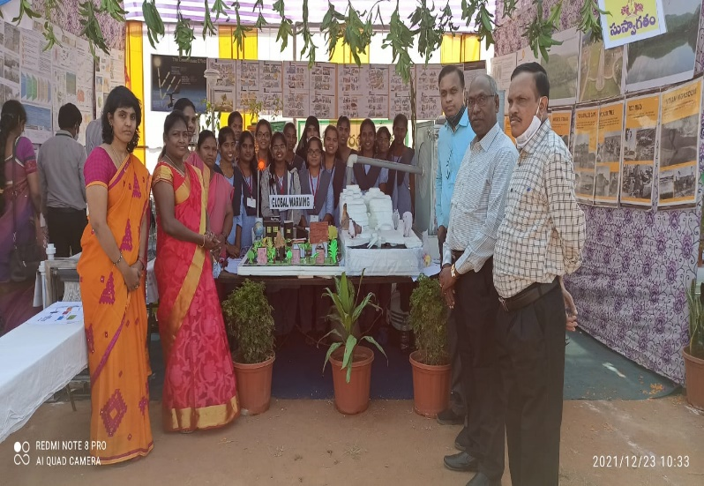  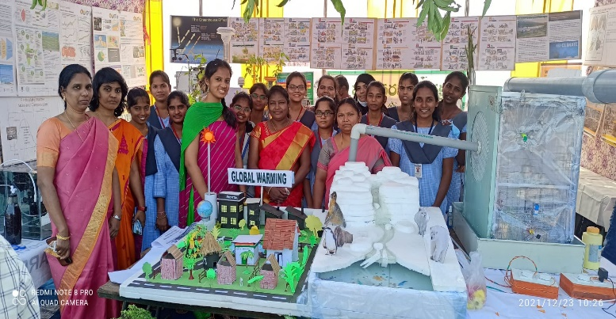  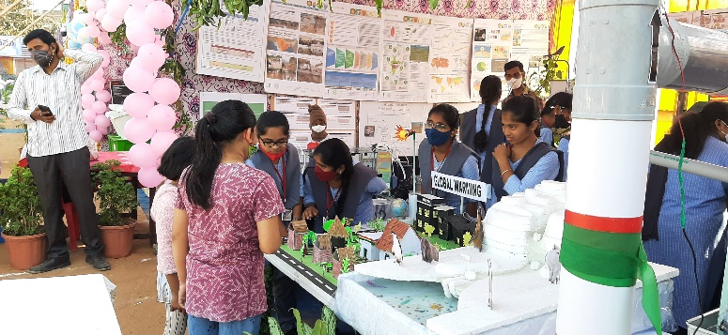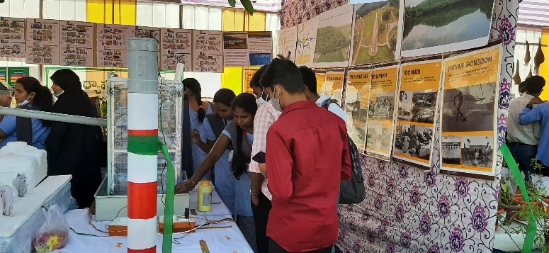
27-12-2021 | Field trip to “Agricultural Research Station”, Madhira with III BSc (Biotechnology) students to gain Hands-on-Experience. | 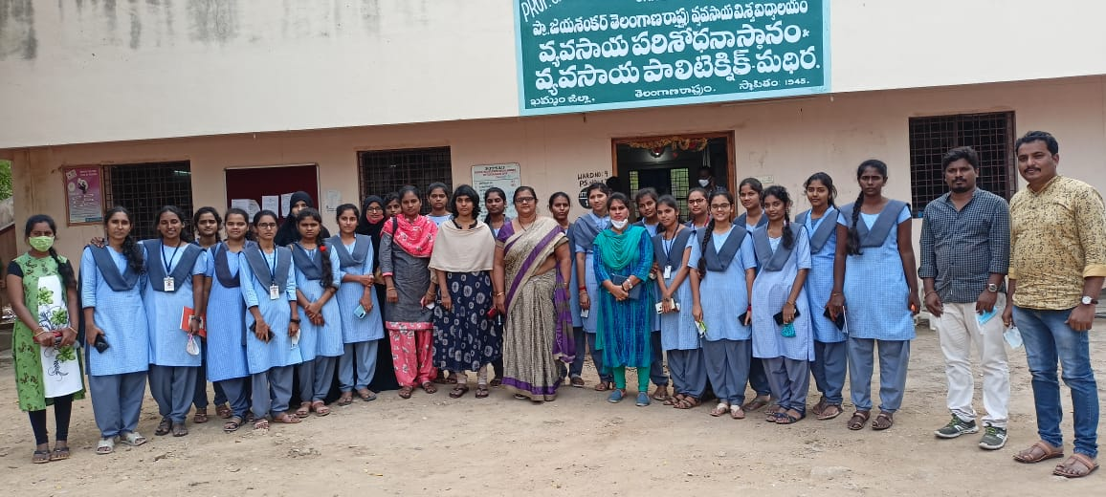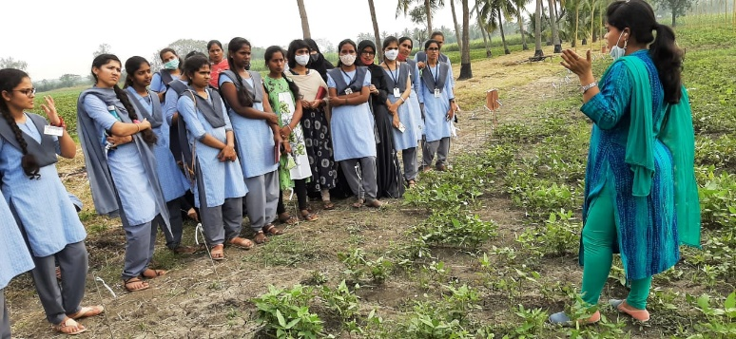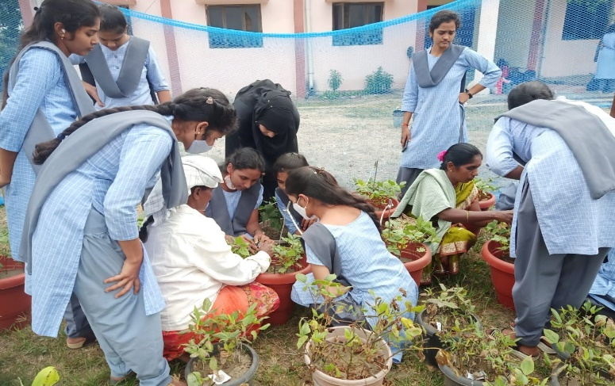
13-01-2022 | Published research paper titled- Gas Chromatographic analysis in leaf and root extracts of Muntingia calabura and their expected antibacterial activities. In International Journal: Natural Resources for Human Health. | 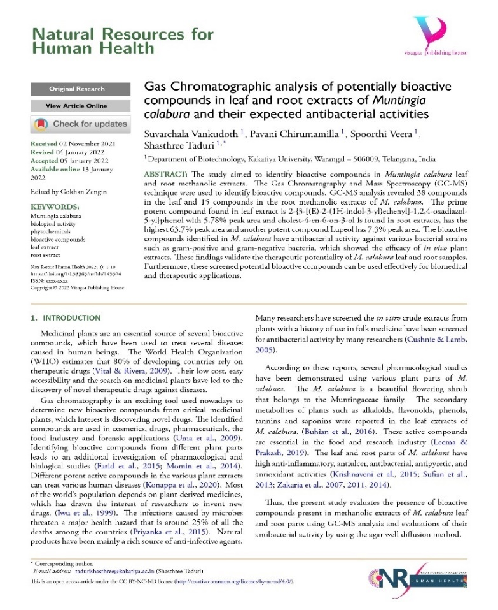
20-01-2022 to 30-1-2022 | Completed EPS (Effective Public Speaking) course, conducted by IMPACT Foundation. | 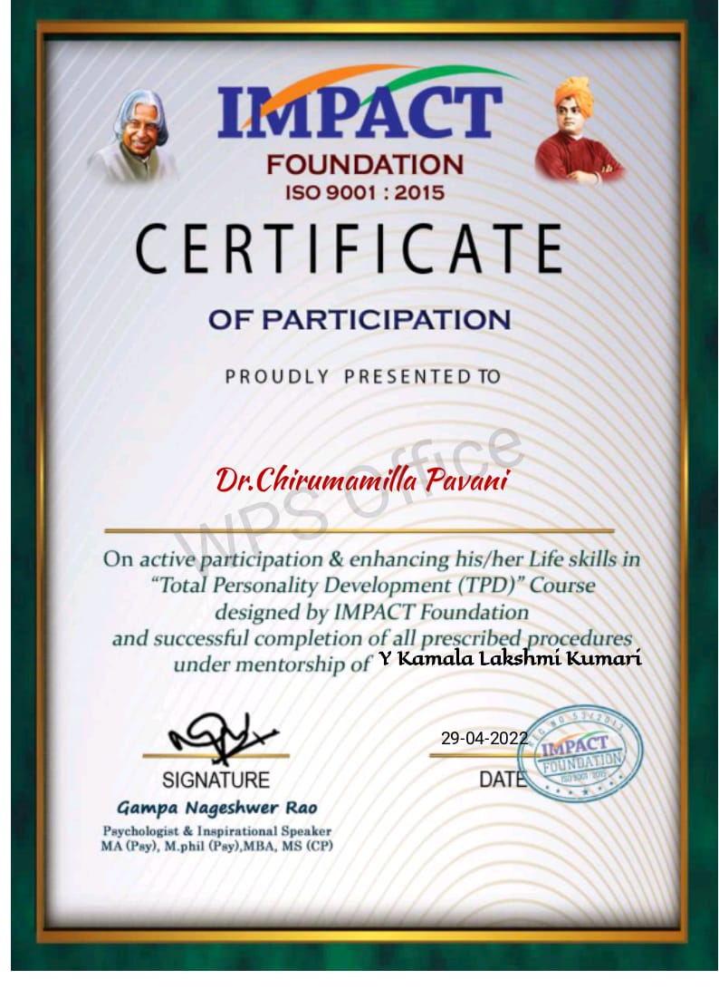
24-01-2022 | Attended “National INNOVATION and STARTUP policy 2019 for Students and Faculty”- organized by IIC, Ministry of Education, Initiative. | 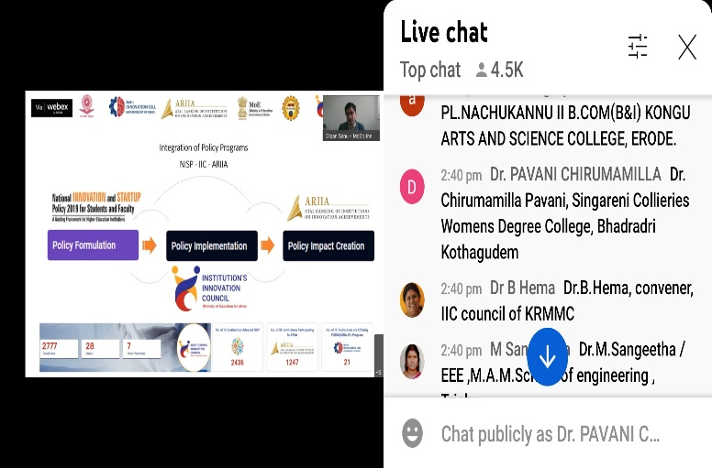
26-01-2022 | Participated in 73rd Republic Day Celebrations at Environment Department. Staff and Students received Appreciation Certificates from Sri. K. Kondaiah, GM (Environment), SCCL for exhibiting Working models in Singareni Day Celebrations. | 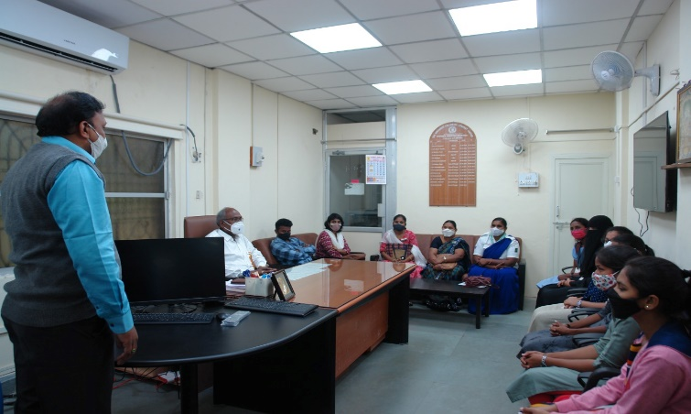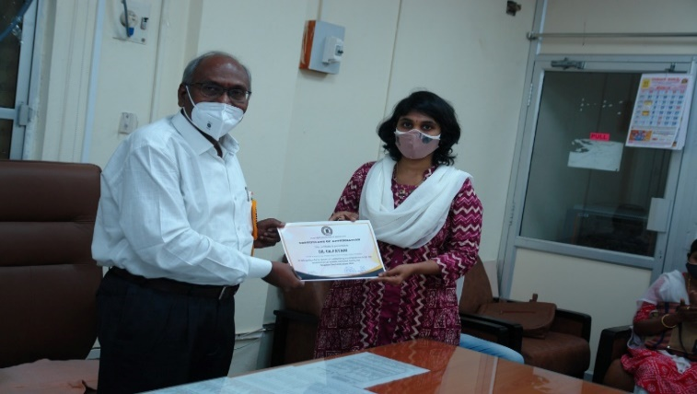  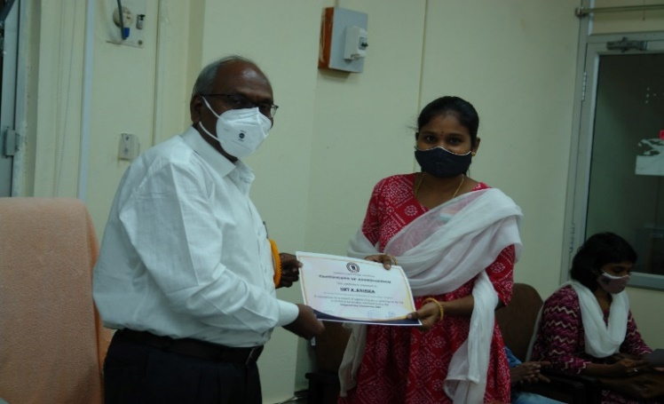
28-01-2022 | Attended “Q & A Session on IIC 4.0: SCRO Zone” Hosted by MOE Innovation Cell.
02-02-2022 | Participated in IGEN SDG Research Survey under the project titled- “SDG-7 Impact on Indian Universities” towards UN Sustainable Development Goals. | 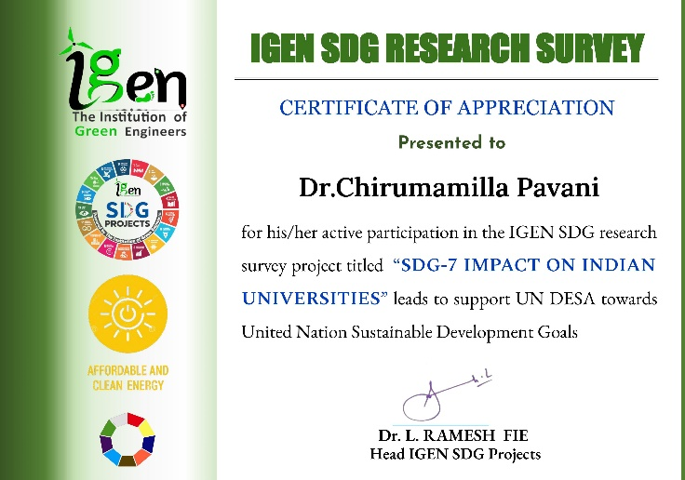
02-02-2022 | Attended one day National Webinar on “Conservation of Wetlands”- organized by ‘Green Belt’, University College for Women, Koti, in collaboration with TS Biodiversity Board. | 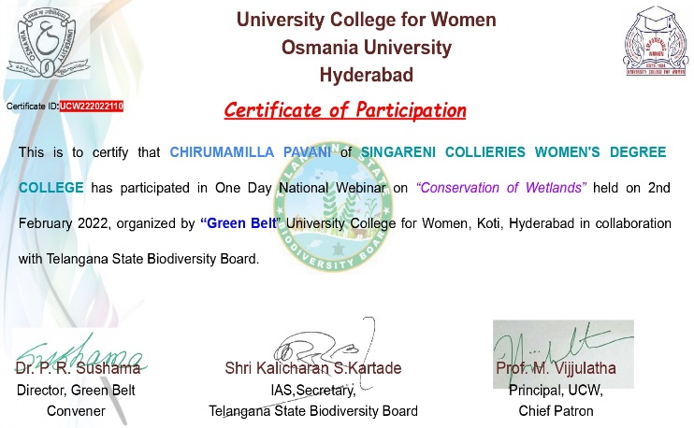
06-02-2022 | Published research paper titled- “Cytotoxicity, DNA Cleavage and Antimicrobial activity of Citrullus colocynthis plant extracts. In International Journal: | 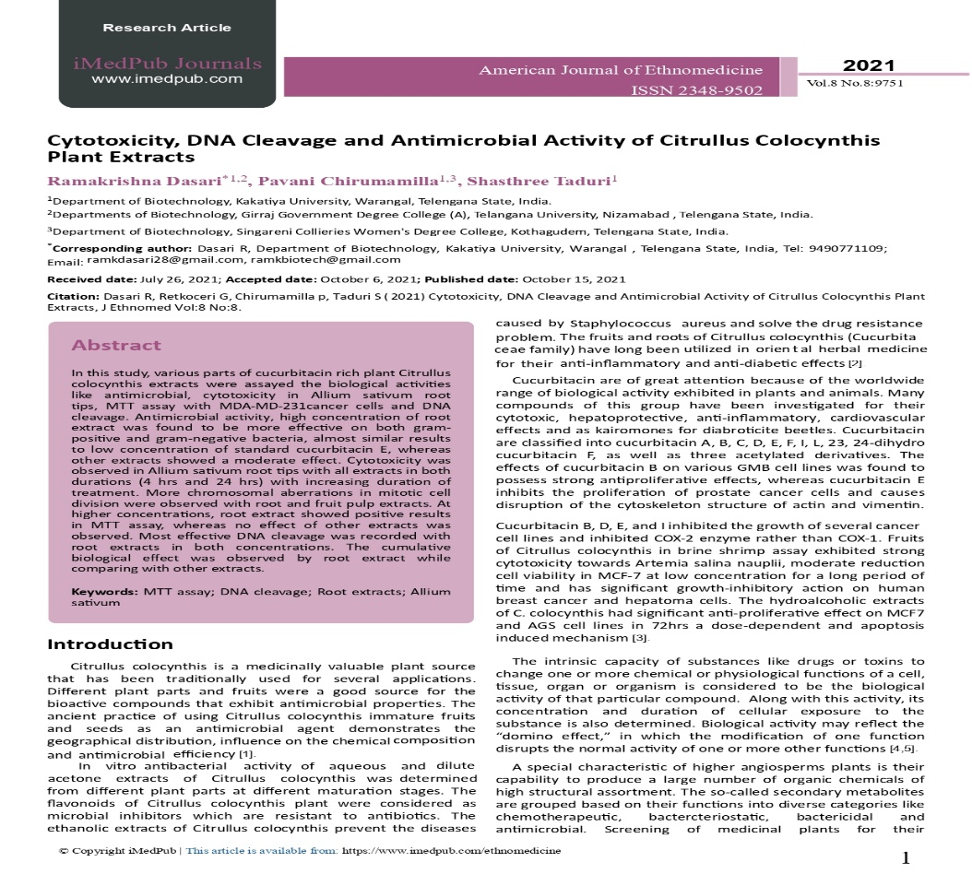
10-02-2022 | Published research paper titled- “In Vitro Anti-Inflammatory Activity of Green Synthesized Silver Nanoparticles and Leaf Methanolic Extract of Solanum khasianum Clarke. In National Research Journal- Proceedings of National Academy of Sciences, India-Section B. Biological Science. https://doi.org/10.1007/s40011-021-01337-9. | 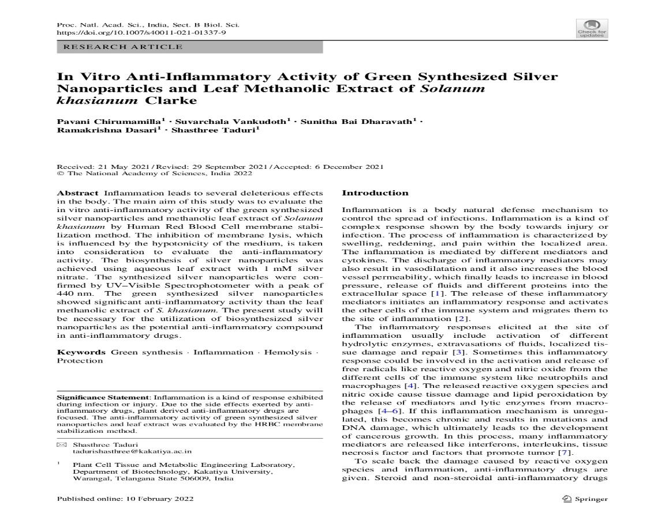
09-03-2022 | Published research article titled- “Green synthesis of silver nanoparticles using Momordica cymbalaria aqueous leaf extracts and screening of their antimicrobial activity”. In National Research Journal- Proceedings of National Academy of Sciences, India-Section B. Biological Science. | 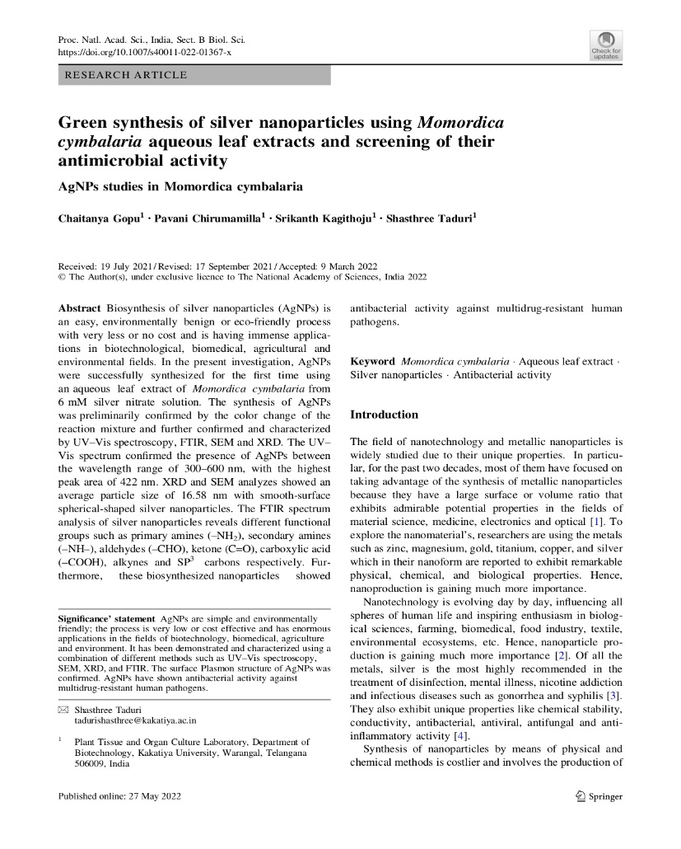
10-03-2022 | Research paper accepted and on online- “GC-MS fingerprinting and antibacterial activity of methanolic extracts of in vitro derived samples of Solanum khasianum”- In International Journal- Journal of Plant Biotechnology | 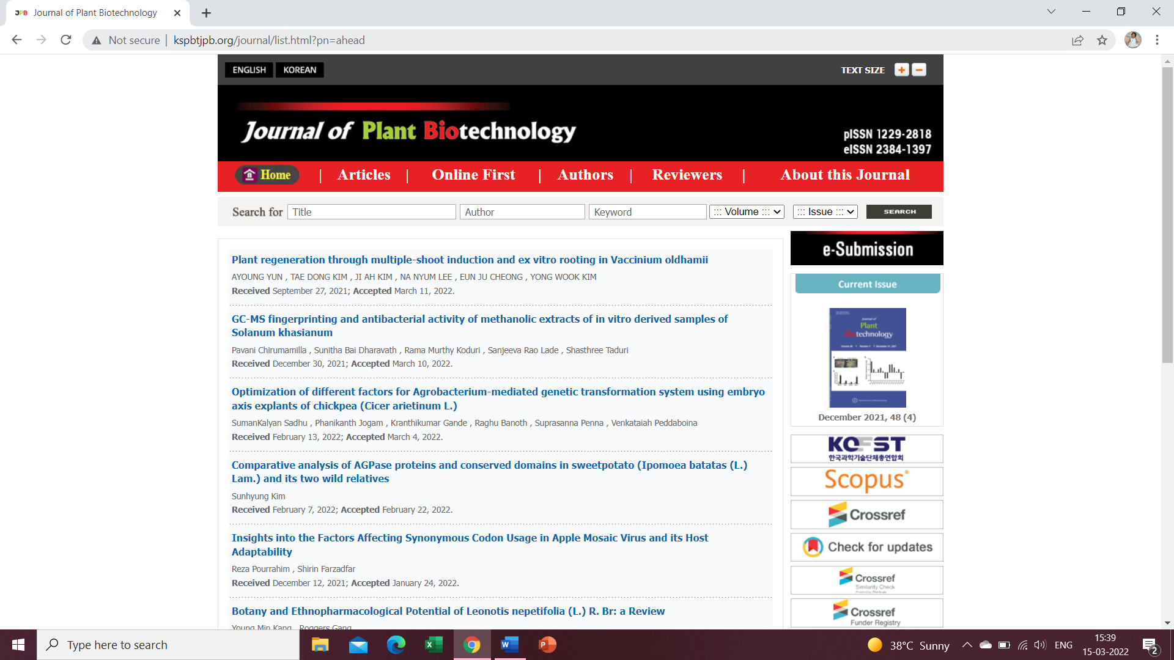
13-03-2022 | Participated in One day Workshop on “HPTLC Technique” conducted by Biodeavour Research Lab. | 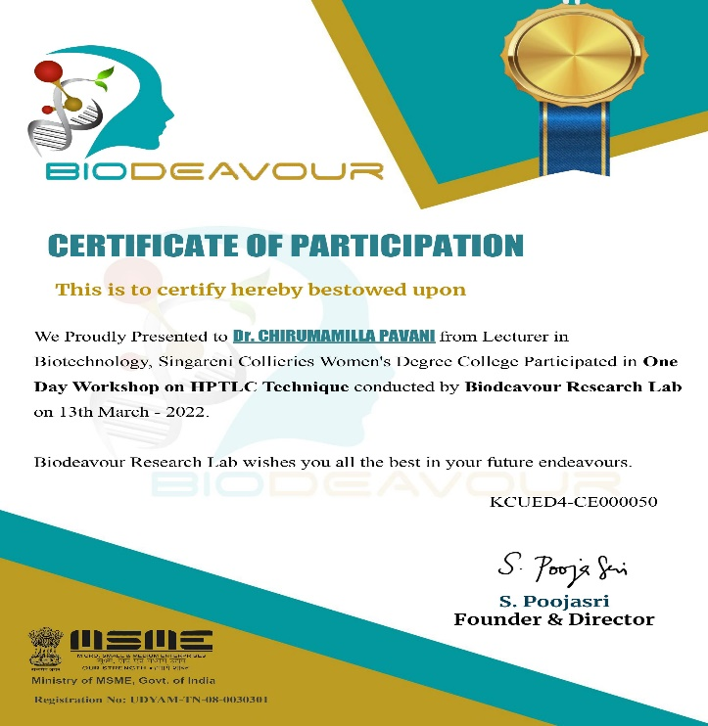
17th-19th Mar 2022 | Participated in Three days National Virtual Workshop on Research Methodology and Data Analysis using MS Excel”- organized by Department of Business Administration, Kamraj College, Tamilnadu. | 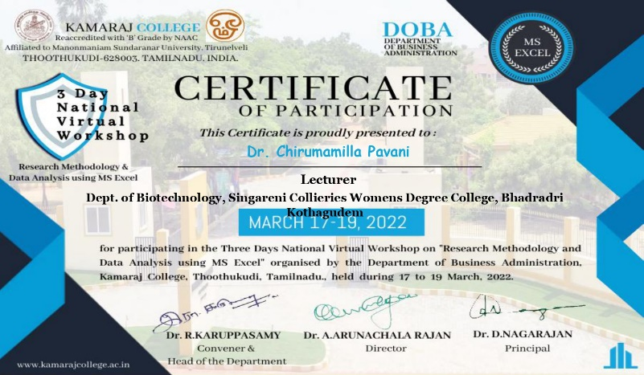
21st -24th Mar 2022 | Judge for “District Level Science Fair 2021-22”, Bhadradri Kothagudem. | 